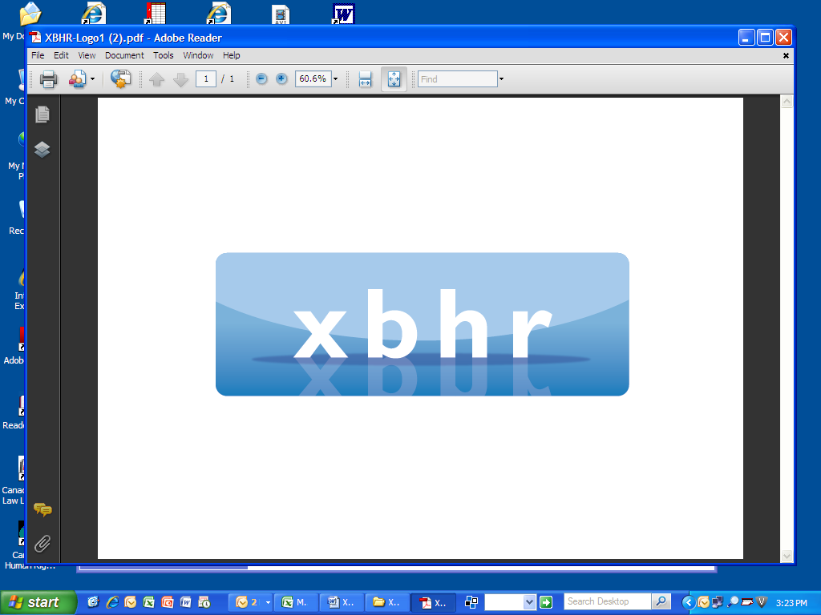

**ANNUAL CONFERENCE**

**The Future Global Workplace – Understanding the HR Challenges Caused by the Accelerator Effect of Technology**

**Paris: 1 –3 March 2017**



**Wednesday, 1 March 2017**

6:30 pm - 9:00 pm **Welcome Cocktails and Networking**

**La Maison de la Recherche**

54 rue de Varenne

75007 Paris

**Thursday, 2 March 2017**

8:00 am Registration Opens

**La Maison de la Recherche**

54 rue de Varenne

75007 Paris

Informal Networking & Light Continental Breakfast

9:00 am Welcome by **Johan Lubbe,** Littler Mendelson, P.C. - Chair of XBHR and **Baba Zipkin,** Millrace Consulting and **Gerlind Wisskirchen**, CMS Hasche Sigle – Vice-Chairs of XBHR

9:15 am Welcome by **Conference Chairs – Roselyn Sands**, EY Law Paris and **Blandine Thibault-Biacabe**, L’Oréal Global HR Legal

9:30 am  **The impact of the global political environment on the workplace of the future.**

*Discussion leaders:*

* Baba Zipkin - Millrace Consulting
* Roselyn Sands – EY Law Paris

We will explore the actual and potential repercussions of recent political and cultural shifts and legislative changes for the labor and employment landscape around the globe. The issues in this discussion should form part of the conversations in the remaining sessions of the conference.

11:00 am Break

11:15 am **Global mobility and the movement of work and workers – HR Challenges.**

*Discussion leaders***:**

* Michael Burd - Lewis Silkin
* Marie Waugh - Suez-NA

This session will examine issues such as:

* How has the globalization of work resulted in changes to traditional cross-border work models?
* Will globalization continue to influence reliance on mobility strategies, or will increasingly nationalistic political movements result in significant decreases in the cross-border exchange of workers?
* What is the increasing impact of local labor law and government regulation upon mobility programs?
* How can HR systems effectively meet corporate compliance obligations imposed by legal requirements (for example, Posted Worker regulations, percentage hiring of local worker requirements, and mandatory local contracts for assignees)?

12:45pm **Annual General Meeting of XBHR**

1:15 pm Lunch

2:15 pm **The impact of demographic shifts and talent challenges on labor models**

*Discussion leaders:*

* Blandine Thibault-Biacabe - L’Oréal Global HR Legal
* Karen Etienne-Sloan – L’Oréal Senior Legal Counsel HR
* Facilitated by Roselyn Sands - EY Law Paris

Discussion in this session will include consideration of changing worker demographics, focusing on the new mindset of the younger generation on work, and specifically employment, given the need for constant challenge and adventure of this population and their desire for greater flexibility in the work relationship. We will explore the impact of the location and availability of skills, where and how work is performed, and the influence of anti-discrimination laws, immigration regulations, and educational policies and programs. How companies are dealing with these trends, and the inescapable legal and HR issues that may arise, will be discussed.

3:30 pm Break

4:00 pm **Technology, Digitization and Robotics – Understanding the Impact on Cross-Border Human Resources**

*Discussion leaders:*

* Gerlind Wisskirchen - CMS Hasche Sigle
* Ajay Raghavan – Trilegal
* Filip Saelens - Loyens & Loeff

Issues we will discuss include:

* Is the “on-demand” economy replacing traditional forms of work?
* What alternative work models are companies implementing, and why? Which are successful?
* Robots and (vs?) people: can they be complementary, or does the use of artificial intelligence models pose an insurmountable threat to the human workforce?
* Is the physical presence of workers determinative of productivity and worker morale, or is the virtual workplace becoming the norm?
* how will HR meet business challenges in light of adjusting employment and work models?
* What are the privacy impacts of the use of technology and robotics?
* The increasing reliance upon Twitter and other social media for business and political communications, and the consequences for the workplace
* Does truth still matter?

5:30 pm Closing Remarks

7:30pm **Cocktail Reception and Dinner**

Restaurant LAPEROUSE

51 Quai des Grands Augustins

75006 Paris

**Sponsored by the generosity of L’Oréal**

**HR Legal**

**Friday, 3 March 2017**

8:00 am Informal Networking & Light Continental Breakfast

9:00 am **Technology, Digitization and Robotics – Understanding the Impact on Cross-Border Human Resources (continued)**

10:30 am Break

10:45 am **New Global Social Corporate Responsibility Challenges for HR and Legal Leadership**

*Discussion leaders:*

* Erin Kuzz - Sherrard Kuzz LLP

Issues to be discussed include:

* The role of public opinion and the media in corporate policy
* Whether the increasing pressure by governments and legislation on corporate conduct is effective to change corporate culture – or do (should?) global corporations influence government policies?
* Will companies in the global marketplace be able successfully to comply with social policy regulations, such as anti-human trafficking reporting and compliance rules?
* Should employees and other workers be constrained by corporate policies – or do individual “rights” prevail?

12:15 pm Lunch

1:15 pm **New Global Social Corporate Responsibility Challenges for HR and Legal Leadership (continued)**

2:30 pm Break

3:00 pm **Global M&A Transactions**

*Discussion leaders:*

* Gunda Niehaus – Proctor & Gamble Germany
* Uli Bormann – Evonik Industries

Discussion issues will include:

* Deficiencies of Global Master Agreements (between ultimate shareholder and target) compared to local requirements
* How to integrate the different stages (due diligence, closing, integration)?
* How to create one team leading the project?
* Best project management
* Timing of transfer of human resource data?
* How to handle expatriate employees?
* Post-Merger Integration:
* Clash of Cultures
* Labor Relations
* Conversions and harmonization of conditions of employment and benefits, including pensions

4:30 pm **Closing Remarks**

4:45 pm **Business Meeting of XBHR Management Committee**

8:00 pm **Voluntary Post-Conference Dinner –** (Somewhere in Paris – TBD according to the number of participants)

*****

We thank the following law firms for their generous sponsorship of this conference:

* Loyens & Loeff
* LABLAW
* Rihm Rechtsanwalte





cid:image004.jpg@01D24C9F.8CCB7220