ANNUAL CONFERENCE
to discuss the key cross-border challenges
and opportunities currently facing the HR profession

Vienna: 25 – 27 February 2015

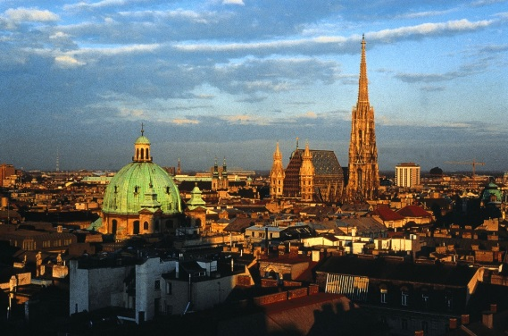

Wednesday, 25 February 2015

6:30 pm - 9:00 pm Welcome Drinks and Networking
Hosted by CMS Reich-Rohrwig Hainz, Gauermanngasse 2, 1010 Vienna

Thursday, 26 February 2015

8:00 am Registration Opens
Hilton Vienna, Am Stadtpark 1, 1030 Vienna, Austria

Informal Networking Breakfast

9:00 am Welcome by Allen Powley, GlaxoSmithKline - Chair of XBHR,
Gerlind Wisskirchen, CMS Hasche Sigle, Gunda Niehaus, Procter & Gamble, Ulrich Bormann, Evonik Industries and Günther Frei, Avaya
- 2015 Conference Co-Chairs

9:15 am Post-Merger/-Acquisition Integration
Moderated by Ulrich Bormann, Evonik Industries, Gunda Niehaus, Procter & Gamble, Gerlind Wisskirchen, CMS Hasche Sigle

10:45 am Break

11:00 am Retaining/Maintaining Talent - Finding the Right People and Keeping Them
- Skill Shortage
- Elderly Employees
- Health Management
- Best Practices in Hiring and Firing Employees
- X and Y Generation
Moderated by Richard Devereux, Intel, Filip Saelens, Loyens & Loeff, Michael Burd, Lewis Silkin, Jorge Aranaz, Cuatrecasas, Marie Waugh, United Water

12:30pm Annual General Meeting of XBHR

12:45 pm Lunch

1:45 pm Compensation & Benefits in a Global Organisation
- Alignment
- Pensions
- Global Risk Assessment
- Benefits, Equity and Severance Pay Plans
Moderated by Ulrich Bormann, Evonik Industries, Lisa Salas, Aon Hewitt

3:15 pm Break

3:30 pm Role of HR in Terms of Change, Adversity and Uncertainty
- Strategic/Operational Approaches to Localization and Operating in Insecure Environments/Crisis Planning
- HR Budgets
- Project Management in Reorganisation
Moderated by Sandro Garofalo, Target Corporation, Roselyn S. Sands, Ernst & Young Société d’Avocats, Beatrice von Brauchitsch, Avaya

5 pm Closing Remarks

6:30pm Drinks Reception and Gala Dinner
Restaurant Plachutta Wollzeile, Wollzeile 38, 1010 Wien, Austria
Sponsored by Epstein Becker, Evonik Industries, Sherrard Kuzz, Thouvenin Rechtsanwälte, Littler, Loyens & Loeff and Procter & Gamble

Friday, 27 February 2014

8:00 am Informal Networking Breakfast

9:00 am Global LR Strategy
- Global Mobility/Immigration
- Restructuring/Rebalancing
- Competitive Restrictions
- Establishing Business Interests in Africa
- Cross-Border Expansion/TUPE rights
- CBAs for Multinational Companies
Moderated by Pat Burke, Malabar Consulting, Baba M. Zipkin, IBM, Erin Kuzz, Sherrard Kuzz, Gunda Niehaus, Procter & Gamble

10:30 am Break

10:45 am Impact of IT on HR
- Key Performance Indicators for HR
- Mobile Office
- Cross-border Project Teams
- Recruiting Process
- Digital Change Management
- Privacy Issues Including with Respect to Electronic Communications and Social Media
Moderated by Günther Frei, Past-Senior Director HR EMEA, Avaya, Suzanne Horne, Paul Hastings

12:15 pm Lunch

1:15 pm Voluntary Leave Programs
- Enforceability/Reasonability of Restrictive Covenants
- Post-employment obligations and restrictions including confidential information
Moderated by Johan Lubbe, Littler, Clare Murray, CM Murray

2:45 pm Insourcing and Outsourcing of Employee Services
- Success Models?
- Joint employer
- Independent contractors
- World of Mobility, Matrix Organisations, and Outsourcing, do you know who your "employees" are?
Moderated by Roselyn S. Sands, Ernst & Young Société d’Avocats, Andrea Schwartz, Western Union

4:15 pm Closing Remarks

4:30 pm Business Meeting of XBHR Management Committee

Accommodation Options

Examples of Hotels near Conference Hotel

Name of the Hotel | Address | Room Type | Guideline  Rate in EUR (per night) | Approx.  Distance from Hilton Vienna
Conference Hotel Hilton Vienna

Hilton Vienna  http://www.hilton.com/en/hi/groups/personalized/V/VIEHITW-GCMSA-20150224/index.jhtml | Am Stadtpark 1  1010 Vienna  Austria  T: +43 (0) 1 717 00 13404 | Single Room  Double Room | €155 room only (incl. of VAT)  €175 room only (incl. of VAT) | Conference Hotel
The following hotels do not offer a discount

(Please note rates shown are the early bird rates on the website. Early bird bookings require payment in full at the time of reservation and are non-refundable)

Marriott | Parkring 12a  1010 Vienna  Austria  T: +43 (0) 1 515 499 7000 | Classic bedroom  Superior bedroom | From  €169 room only (incl. of VAT)  From  €189 room only (incl. of VAT) | 7 minute walk
InterContinental | Johannesgasse 28  1010 Vienna  Austria  T: +43 (0) 1 711220 | Classic Room  Deluxe Room | From €199 room only (incl. of VAT)  From € 249 room only (incl. of VAT) | 9 minute walk

Le Méridien Vienna | Opernring 13-15  1010 Vienna  Austria  T: +44 (0) 207 629 7522 | Superior room  Deluxe room  Executive room | From  €169 (incl. of VAT)  From  €194 (incl. of VAT)  From  €219 (incl. of VAT) | 13 minute walk

